Track Applications Results Display Function – CGEA1.3

Functional Description

The purpose of the Track Applications Results Display function is to provide the user the ability to view and maintain the accelerometer, acceleration timer and brake performance records that he might have collected during his test runs. The View/Clear results screens are only available when the vehicle is in stationary position (not moving). If the vehicle speed exceeds 8 KPH while the cluster is displaying the results screen, the cluster shall return to the Track Apps Menu selection screen.

The Track Applications Results Display function has 3 sets of data stored:

- Last run data: This data is stored at the successful completion of an acceleration timer or a brake performance run. This entire set of data is overwritten at the next run. If any values are not completed in a run, the values will be blank. The last run data should be retained until the next run overwrites the data or until the customer clears the saved and last run data.
- Saved Data: The customer can elect to save any of the last run data. Saved data is not overwritten on the next successful run. Saved data shall remain in the cluster memory unless it is overwritten by the customer or cleared using the “Clear Saved” selection from the menu.
- All Time Best Data: This data is automatically collected out of the last run data. If the current All Time Best Data is worse than the last run data, the last run data is stored as the All Time Best Data. Each metric is handled and saved separately. This data can only be deleted by using the “Clear All Time Best” data from the menu.

The Track Applications Results Display function correlates the outputs from the Acceleration Timer Control Function STSS, the Brake Performance Control Function STSS, and the Operational mode to display the appropriate data.

Interfaces

Interface Context Diagram (I/O Block Diagram)
Figure 1.0 Track Applications Results Display Function Context Diagram
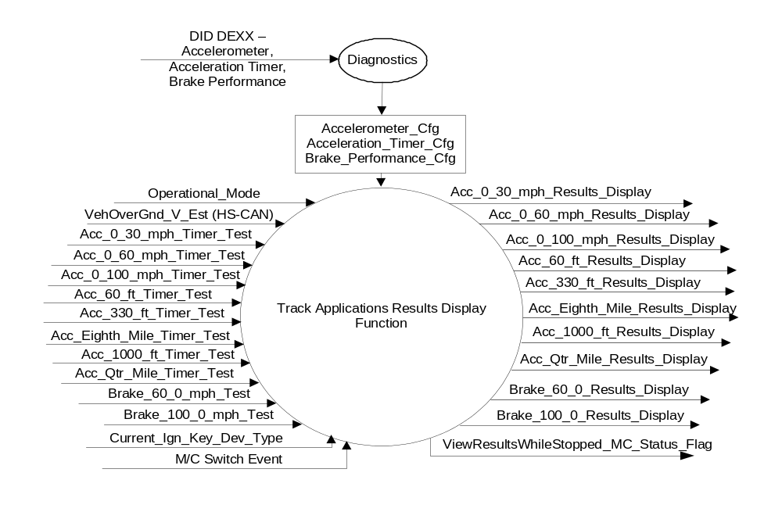

Inputs
- INTERNAL:
  - Operational_Mode: Refer to section Operational Modes
  - Current_Ign_Key_Dev_Type: Used to indicate the type of key currently in use in the vehicle. See MyKey Control Function SPSS for further definition
  - Accelerometer_Cfg – Refer to the Accelerometer Display STSS for more information
  - Acceleration_Timer_Cfg – Refer to the Acceleration Timer Control Function STSS for more information.
  - Brake_Performance_Cfg – Refer to the Brake Performance Control Function STSS for more information.
  - M/C Switch Event
Refer to the Acceleration Timer Control Function STSS for more information on the following inputs.
  - Acc_0_30_mph_Timer_Test
  - Acc_0_60_mph_Timer_Test
  - Acc_0_100_mph_Timer_Test
  - Acc_60_ft_Timer_Test
  - Acc_330_ft_Timer_Test
  - Acc_Eighth_Mile_Timer_Test
  - Acc_1000_ft_Timer_Test
  - Acc_Qtr_Mile_Timer_Test
Refer to the Brake Performance Control Function STSS for more information on the following inputs
  - Brake_60_0_mph_Test
  - Brake_100_0_mph_Test
- MUX messages on the HS_CAN Bus

- VehOverGnd_V_Est (HS_CAN) Signal
Signal Name | Size (bits) | Detail | Units | Res. | Offset | State Encoded | Min | Max
VehOverGnd_V_Est | 10 |  | kph | 0.01 | 0 |  | 0 (0x0) | 655.33 (0xFFFD)
 |  | Unknown |  |  |  | 0xFFFE
 |  | Fault |  |  |  | 0xFFFF

Outputs
- Acc_0_30_mph_Results_Display
- Acc_0_60_mph_Results_Display
- Acc_0_100_mph_Results_Display
- Acc_60_ft_Timer_Results_Display
- Acc_330_ft_Timer_Results_Display
- Acc_Eighth_Mile_Timer_Results_Display
- Acc_1000_ft_Timer_Results_Display
- Acc_Qtr_Mile_Timer_Results_Display
- Brake_60_0_mph_Results_Display
- Brake_100_0_mph_Results_Display
- ViewResultsWhileStopped_MC_Status_Flag

Function/Performance

Operational Modes

Mode | Differentiating Vehicle Conditions
Sleep Mode | XXX_Results_Display Inactive
Limited Mode | XXX_Results_Display Inactive
Normal Mode | XXX_Results_Display Active / Inactive
Crank Mode | XXX_Results_Display Active / Inactive

Voltage Levels

Refer to Cluster Features table located in the Operational Modes and Voltage Range Strategies section in this SPSS.

Human-Machine Interface

Visual

Indicator Graphics / Display Format
Some example graphics for the 4.2” TFT (not all graphics are shown here):
- An option to “Clear Accelerometer Data” shall be added to the menu in screen #3.

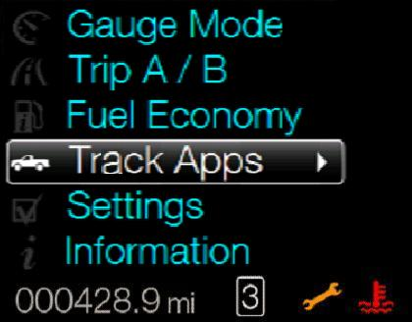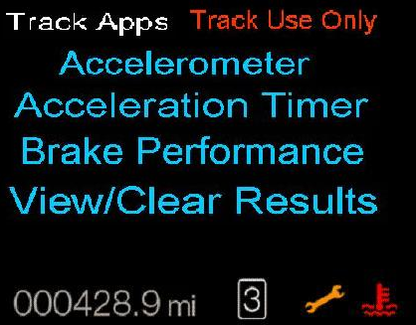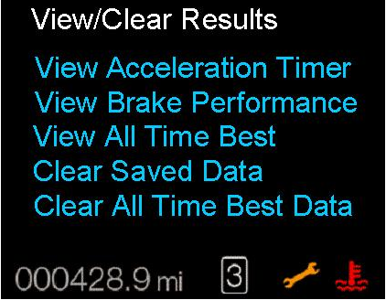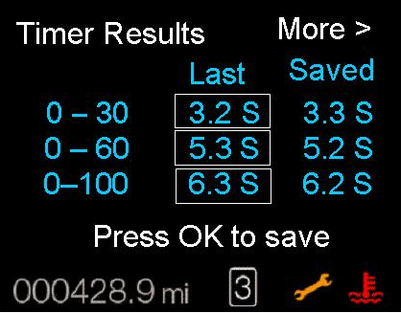
1 2 3 4

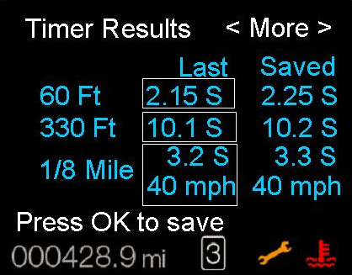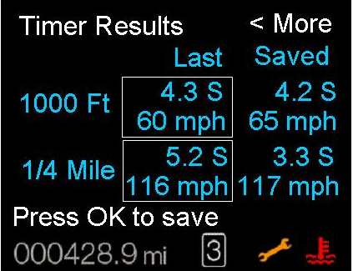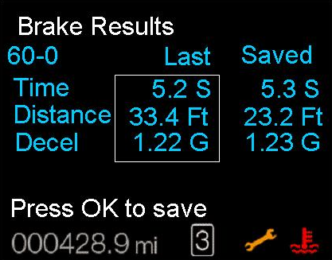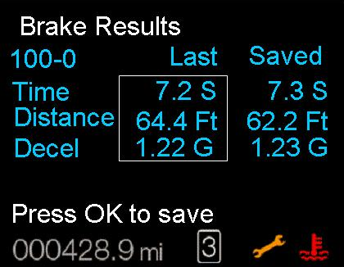
5 6 7 8

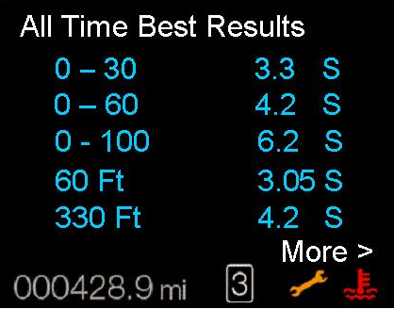 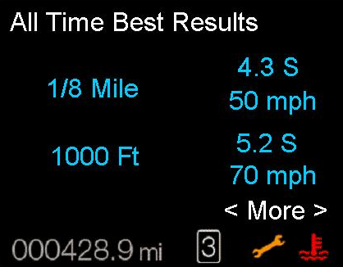 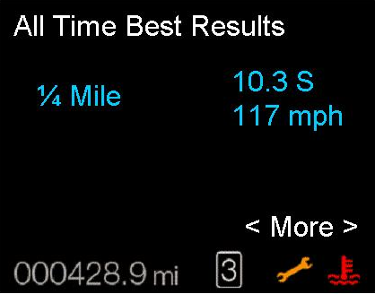 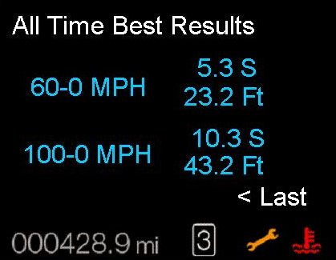 9 10 11 12

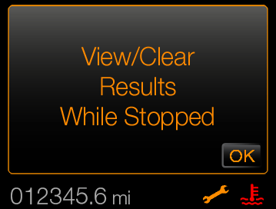
13
Note: 13 above is a TA warning (W3263) message which is displayed upon
ViewResultsWhileStopped_MC_Status_Flag = Active

Indicator Color Coordinates

Indicator Characteristics

Audio

None

Switch Control Logic

Not applicable.

System Accuracy

The XXX_Results_Display shall accurately display the data acquired during the Acceleration Timer and Brake performance tests.

Operation: Performance and Functional

Subsystem Algorithm Flowchart / State Diagram

Figure 1.1 Track Applications Results Display Function

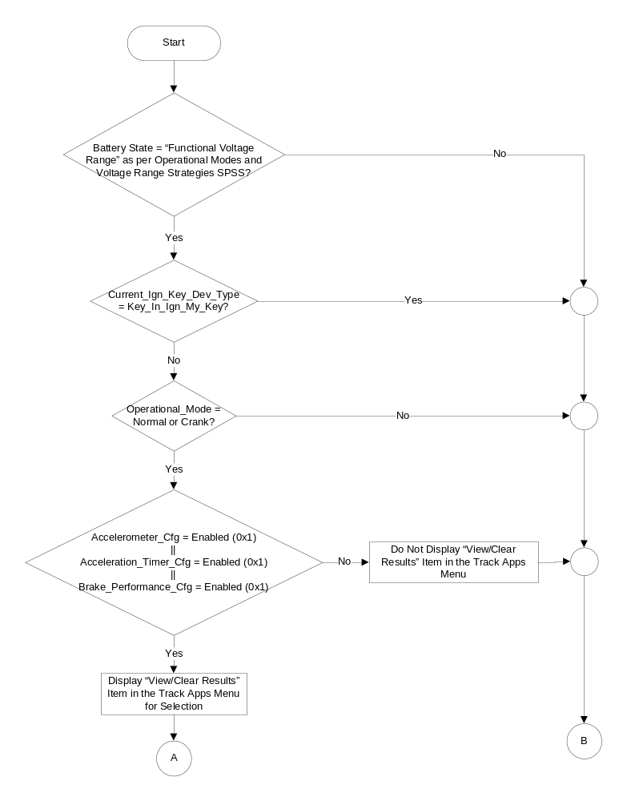
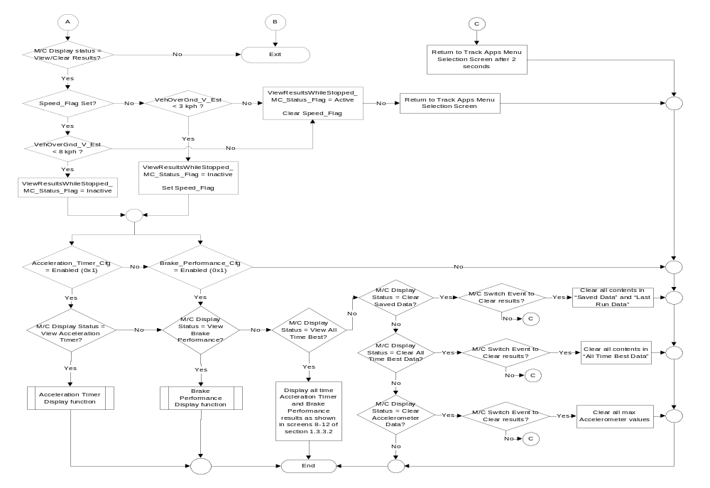
Figure 1.2 Acceleration Timer Display Subroutine
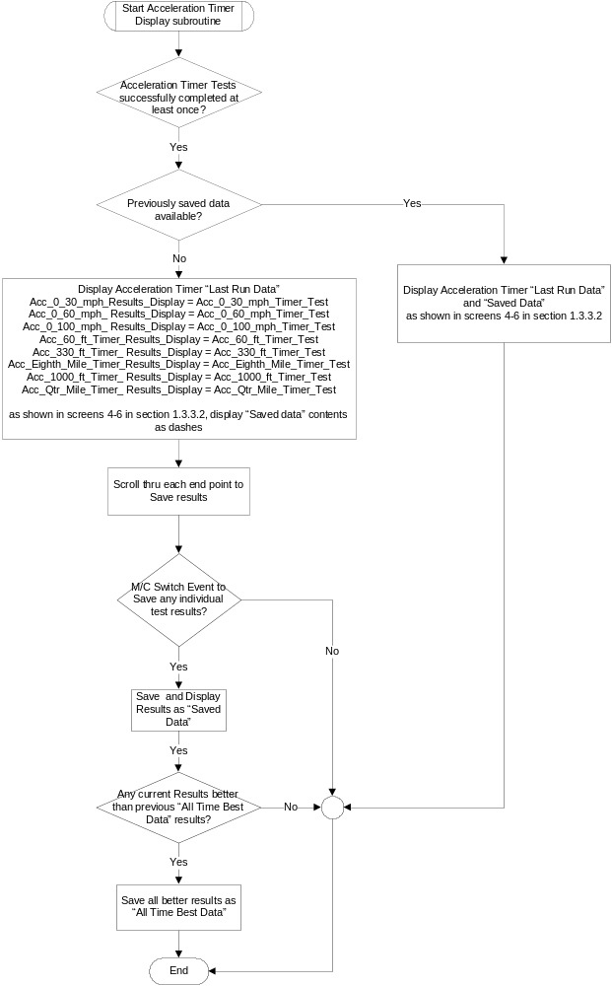
Figure 1.3 Brake Performance Display Subroutine

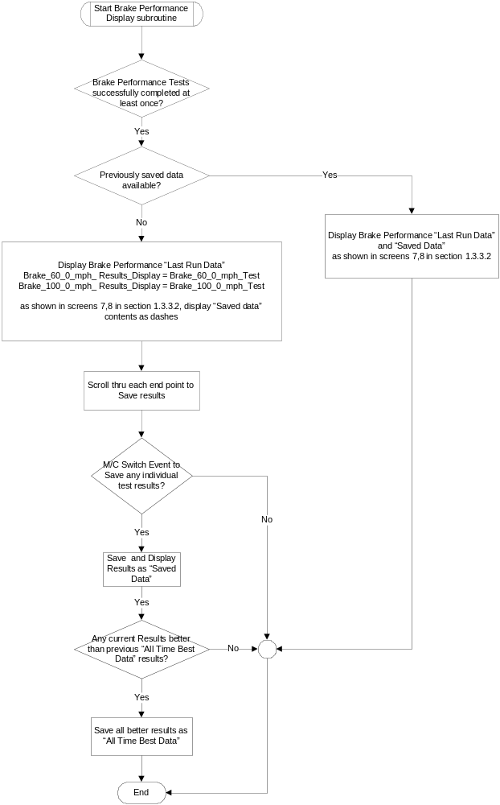

Operation Description (supports algorithm flowchart /state diagram)

- View/Clear Results while Stopped Status Flag to Display Mapping
Operational_ Mode | Track_Apps_ Results_Cfg | ViewResultsWhileStopped_  MC_Status_Flag | Display  (W3263)
Normal or Crank | Enabled | Active | VIEW/CLEAR RESULTS WHILE STOPPED

- All the screens under the Acceleration Timer menu shall display “Track Use Only” on the screen at all times.
- The screens under the View/Clear Results menu selection shall not be displayed when the vehicle is in motion. If the vehicle speed exceeds 8 KPH while the View/Clear screens are actively displayed, the cluster shall return to the Track Apps menu selection screen.
- The cluster shall continue to display the data in the Track Applications Results Display function if VehOverGnd_V_Est signal is declared missing, invalid or unknown.

The Track Applications Results Display function has 3 sets of data stored:

- Last run data: This data is stored at the successful completion of an acceleration timer or a brake performance run. This entire set of data is overwritten at the next run. If any values are not completed in a run, the values will be blank. The last run data should be retained until the next run overwrites the data or until the user clears the saved and last run data. The last run data shall be retained over ignition cycles until over written by next successful run or cleared by the user.
- Saved Data: The user can elect to save any of the last run data. Saved data is not overwritten on the next successful run. Saved data shall remain in the cluster memory unless it is overwritten by the user or cleared using the “Clear Saved” selection from the menu.
- All Time Best Data: This data shall be collected out of the last run data. If the current All Time Best Data is worse than the last run data, the last run data is stored as the All Time Best Data. Each metric is handled and saved separately. This data can only be deleted by using the “Clear All Time Best” data from the menu.
- The following data shall be saved and displayed (upon request) under the “All Time Best Data”:
- 0-30 MPH speed test: Time in seconds
- 0-60 MPH speed test: Time in seconds
- 0-100 MPH speed test: Time in seconds
- 60 feet speed test: Time in seconds
- 330 feet speed test: Time in seconds
- 1/8th Mile speed test: Time in seconds, Speed in MPH
- 1000 feet speed test: Time in seconds, Speed in MPH
- ¼ Mile speed test: Time in seconds, Speed in MPH
- 60-0 MPH brake test: Distance in feet, Max Decceleration, Time in seconds
- 100-0 MPH brake test: Distance in feet, Max Decceleration, Time in seconds
- The cluster shall allow the capability of saving each test point data individually (for speed and brake tests). The exception to this is when a test point data includes both time and speed (in case of a speed test), the two values shall be saved together (i.e. ¼ mile time and ¼ mile speed saved together).
- The cluster shall clear all available “All Time Best” data when the option to “Clear All Time Best” is selected by the user.
- The cluster shall clear all available “Last Run Data” and “Saved Data” when the option to “Clear Saved Data” is selected by the user.
- The Track Apps feature shall not be available if Track_Apps_Cfg is set to disabled (0x0).
- The Track Apps feature shall not be available if the vehicle is driven using My Key (Current_Ign_Key_Dev_Type = Key_In_Ign_My_Key).

Function Safety Classification (EMC)

Class B

Memory Storage

Parameter Name | Description | Value at Battery Connect | Value at Module Wake-up
VehOverGnd_V_Est (HS-CAN) | Vehicle speed input from ABS_ESC. | 0 kph (0x0) | 0 kph (0x0)
Acc_0_30_mph_Timer_Test  Acc_0_60_mph_Timer_Test  Acc_0_100_mph_Timer_Test  Acc_60_ft_Timer_Test  Acc_330_ft_Timer_Test  Acc_Eighth_Mile_Timer_Test  Acc_1000_ft_Timer_Test  Acc_Qtr_Mile_Timer_Test | Input variables from the Acceleration Timer Control Function STSS. | Use Stored values | Use Stored values
Brake_60_0_mph_Test  Brake_100_0_mph_Test | Input variables from the Brake Performance Control Function STSS. | Use Stored values | Use Stored values
Acc_0_30_mph_Results_Display  Acc_0_60_mph_Results_Display  Acc_0_100_mph_Results_Display  Acc_60_ft_Timer_Results_Display  Acc_330_ft_Timer_Results_Display  Acc_Eighth_Mile_Timer_Results_Display  Acc_1000_ft_Timer_ Results_Display  Acc_Qtr_Mile_Timer_ Results_Display  Brake_60_0_mph_ Results_Display  Brake_100_0_mph_ Results_Display | Output displays, shows results of the last run, saved and all time best data for acceleration and brake performance tests. | Inactive | Inactive
Accelerometer_Cfg | State indicator for feature presence controlled via CAN at EOL at VO plant. Set to Disabled at Cluster Supplier Manufacturing Plant | Use Stored Value | Use Stored Value
Acceleration_Timer_Cfg | State indicator for feature presence controlled via CAN at EOL at VO plant. Set to Disabled at Cluster Supplier Manufacturing Plant | Use Stored Value | Use Stored Value
Brake_Performance_Cfg | State indicator for feature presence controlled via CAN at EOL at VO plant. Set to Disabled at Cluster Supplier Manufacturing Plant | Use Stored Value | Use Stored Value
M/C Switch Event | Event that is indicated as per the switch interface for the Message Center. See * | See * | See*
ViewResultsWhileStopped_MC_Status_Flag | Used to control the state of the display for the Message Center arbitrator | Inactive | Inactive
Speed_Flag | Internal flag to determine if okay to display results | Clear | Clear
Operational_Mode | 4 state indicator for cluster operational mode | Limited | Limited or Normal or Crank
* Refer to Message Center X Display_Y Button Interface Section, where X and Y are appropriate values in this document.

Prove Out

No

Error Handling

Missing Message Strategy

Missing Message strategy is covered under the “Acceleration Timer Control Function” STSS.

The screens in the Track Applications Results Display function shall continue to operate normally if message 0x74 is declared missing.

Invalid Message Strategy

Invalid Message data strategy for signals is covered under the “Acceleration Timer Control Function” STSS.

The screens in the Track Applications Results Display function shall continue to operate normally if the speed signal is declared invalid.

Unknown Message Strategy

Unknown Message data strategy for signals is covered under the “Acceleration Timer Control Function” STSS.

The screens in the Track Applications Results Display function shall continue to operate normally if the speed signal is declared unknown.

Diagnostics

Self Test
None

Engineering Test Mode
Reference section “Dealer / Engineering Test Mode (ETM)”

Part II Performance
Reference Part II Diagnostic Specification

Supported Diagnostic Trouble Codes (DTCs)

CAN network related DTCs are covered under the “Acceleration Timer Control Function” STSS.

Reference Specification

- Func. Criticality EC-0048
- Mod. PWR-up / Reset EC-0049
- Low-High Vol. Perform. EC-0058
- Oper. Voltage Perf. IS-0052
- Oper. Voltage Func. IS-0053
- Symbol Usage 01-0238 / 01-0239
- Symbol Leg. 01-0240
- Placement - Parts Loc. 03-0001
- Glare/Reflections 16-0068
- Reflection 17-0018
- Harmony: Graphics / Font / Ill. 17-0040
- Ergo - Access. 17-0052
- Ergo - Operablility 17-0053
- Control & Display Loc. 17-0060
- Logical grouping Function and Usage 17-0062
- Assoc. of Controls with Disp. & elem. 17-0063
- Ill. Controls & Disp. 17-0074
- Id. Legibility 17-0081
- ID. Coding / Labeling 17-0083
- Logic of Op. 17-0120
- Op. Stereotypes 17-0121
- Interpretation 17-0122
- Feedback 17-0124

Revision History

SPSS Module Revision History

Revision Level | Name | Change Description | Date
1.0 | V. Patel | Initial version for CGEA1.3, leveraged from 2013 S197 “Track Applications Results Display Function” STSS version 2.0 | 09/04/2012
1.1 | Mlenkner | Replaced Track_Apps_Cfg with Track_Apps_Results_Cfg throughout | 12/11/12
1.2 | V. Patel | - Changed DE00 to DEXX since there are more than one configuration blocks.  - Removed “Track_Apps_Results_Cfg” bit since it is not required. Replaced it with “Accelerometer_Cfg”, “Acceleration_Timer_Cfg” and “Brake_Performance”Cfg” to check if the Track Apps results should be displayed or not.  - Modified figure 1.0, figure 1.1 and the table in section 1.3.5.4 to reflect the inclusion of 3 configuration checks.  - Deleted DEXX block from section 1.5 since config bits are defined in individual STSS documents that are referenced in this document.  - Added warning ID W3263 for the “View/Clear Results While Stopped” display. | 3/5/2013

